**Visualization of the fitted curves**

a. Draw separate plots of all 9 different curves that you have fit for the training dataset in 1b.

The fit plots for training dataset are below:

N=1 N=2

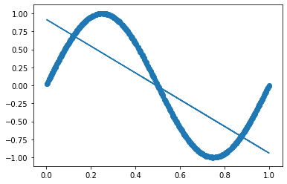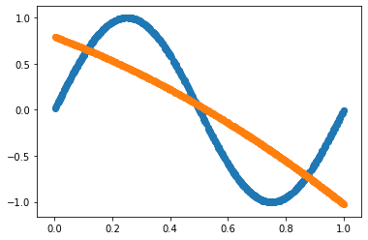

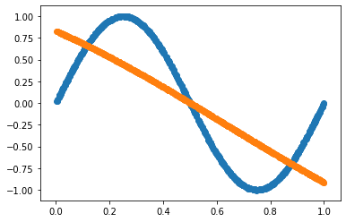 N=3 N=4

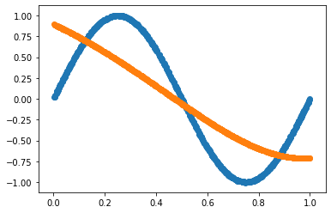

N=5

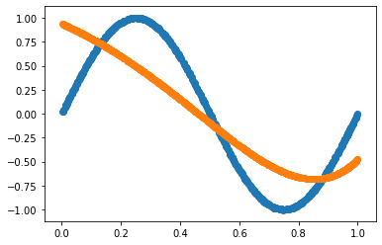

N=6

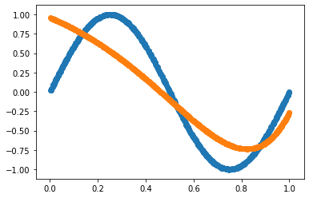

N=7

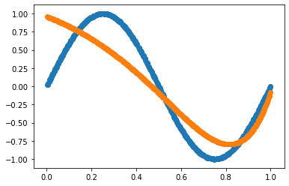

N=8

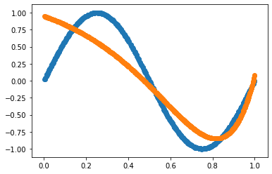

N=9

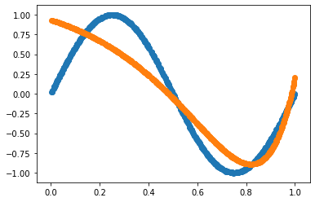

b. Report squared error on both train and test data for each value of n in the form of a plot where along x-axis, vary n from 1 to 9 and along y-axis, plot both training error and test error. Explain which value of n is suitable for the dataset that you have, and why.

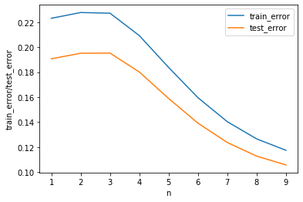

From the above plot, we see that a suitable value for the ‘Regression’ for the above dataset would be **n = 9** because this value of n minimizes the training and test error as well as it also minimizes the difference of training and test error which rules out any presence of overfitting.

From the above plot,

Minimum Training error: n=9

Maximum Training error: n=2